**Project Design Phase-II**

**Data Flow Diagram & User Stories**

|  |  |
| --- | --- |
| Date | 26 June 2025 |
| Team ID | LTVIP2025TMID31972 |
| Project Name | HealthAl: Intelligent Healthcare Assistant Using IBM Granite |
| Maximum Marks | 4 Marks |

**Data Flow Diagrams:**

A Data Flow Diagram (DFD) is a traditional visual representation of the information flows within a system. A neat and clear DFD can depict the right amount of the system requirement graphically. It shows how data enters and leaves the system, what changes the information, and where data is stored.**Example:** [**(Simplified)**](https://developer.ibm.com/patterns/visualize-unstructured-text/)

Example: DFD Level 0 (Industry Standard)

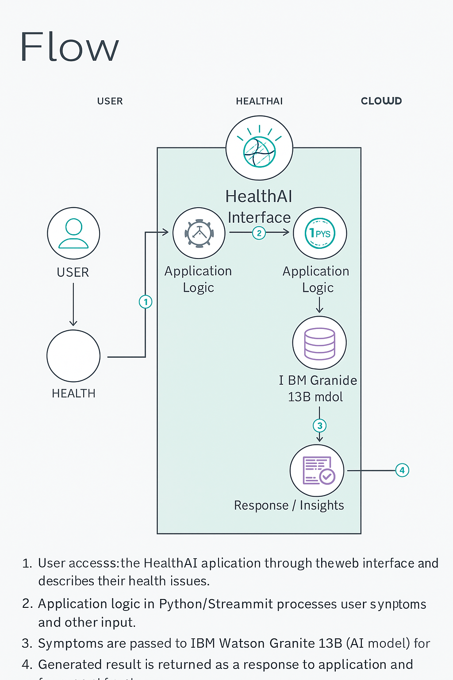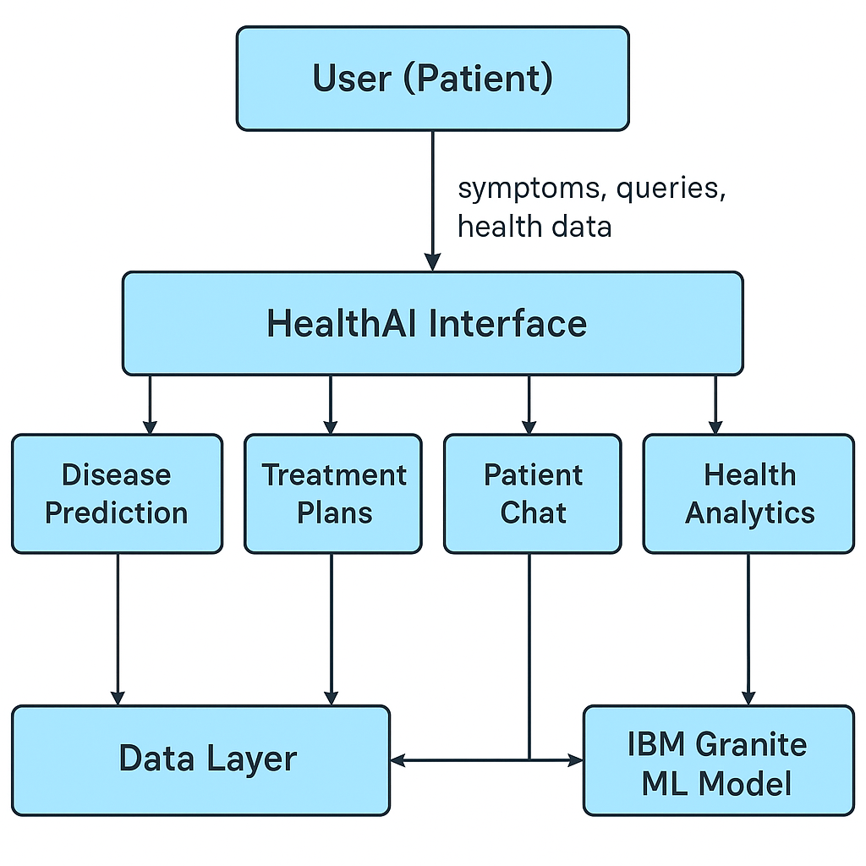

**User Stories**

Use the below template to list all the user stories for the product.

| **Functional Requirement (Epic)** | **User Story Number** | **User Story / Task** | **Acceptance criteria** | **Priority** | **Release** |
| --- | --- | --- | --- | --- | --- |
| User profile | USN-1 | As a user, I can log in using my credentials | I am redirected to the HealthAI dashboard | High | |  | | --- | |  |  |  | | --- | | Sprint-1 | |
| Disease Prediction | USN-3 | As a user, I can enter my symptoms to get possible conditions | I receive a list of likely conditions with confidence scores | High | Sprint-1 |
| Health AI Bot | USN-2 | As a returning user, my past health data is used to improve prediction accuracy | Predictions are more personalized based on my history | Medium | Sprint-2 |
| Treatment Plans | USN-4 | As a user, I can get treatment plans for known conditions | I receive medication, lifestyle, and follow-up advice | High | Sprint-1 |
| Health Analytics | USN-5 | As a user, I can track my vitals like BP, sugar, and heart rate over time | I see charts and get improvement insights | High | |  | | --- | |  |  |  | | --- | | Sprint-2 | |
| Health Analytics | USN-6 | As a user, I can integrate wearable devices | My health data is updated automatically | Medium | Sprint-3 |
| Notifications | USN-7 | As a user, I want regular health reminders | I receive notifications for checkups and tips | Medium | |  | | --- | | Sprint-3 |  |  | | --- | |  | |
| User Management | USN-8 | As an admin, I can view and manage user accounts | I can suspend, delete, or update user details | High | Sprint-2 |
| AI Model Monitoring | USN-9 | As an admin, I can monitor AI responses for accuracy and appropriateness | I see logs and performance analytics of the model | High | Sprint-3 |
| Chat history | USN-10 | As a support agent, I can assist users with history of chats or health data issues | I can access the chat history | High | Sprint-2 |